Bakery Product Analysis
Rhianna Ruggiero

Introduction
A problem experienced by many bakeries is knowing how much of a product to purchase or make every night so that they can sell as many items as possible without having a lot of waste leftover. Many bakeries only sell the items that they make the morning of, so if they overestimate how much that they will sell then a lot of the food will go to waste since it may not be able to be sold the next day. Alternatively, if they underestimate how much they are going to see then they will be missing out on potential sales. It can be difficult to predict how many sales there will be on a given day but being able to predict sales based on historical sales information can help give the bakery an idea of how much they may sell on a given day of the week. For example, they might see that a certain item like coffee sells the most on Mondays, but bread has the highest sales on Sundays. To do this, I will need historical sales of baked and other goods and the day of the week that the item was sold. I will need to create a model to predict the number of sales on each day of the week. The question that I am trying to address is how much of an item should the bakery have readily available each day of the week to maximize sales and minimize waste? To pitch this idea to stakeholders I would gather data based on how much product goes to waste each day originally at the bakery. If a lot of product goes to waste, I would show how much money and time is being wasted on creating goods that don’t ever gain a profit. Alternatively, if all of the products sell out early each day then I would show how the bakery is missing out on potential sales if more items were readily available. The dataset that I am using is from Kaggle and contains transaction details from online purchases from a bakery in Edinburgh from October 2016 to April 2017. The name of the bakery is “The Bread Basket” and can be found at this link: https://www.kaggle.com/datasets/akashdeepkuila/bakery?select=bakery_sales_revised.csv
Summary of Milestones
First I explored the data that I had from the bakery sales and I converted columns to be the correct data type. For example, I made sure that the date column was date time. I then also added a column that wrote out the name of the day of the week so that I could do an analysis related to that. I then decided to look at just bread sales and to see which days had the most sales in the entire data set. I filtered the data set to only bread items, and I sorted the dataset by day of the week so that I could easily see how sales change throughout the week. Next I grouped the number of items sold by day of the week for bread and created a chart to show which days had the highest sales.
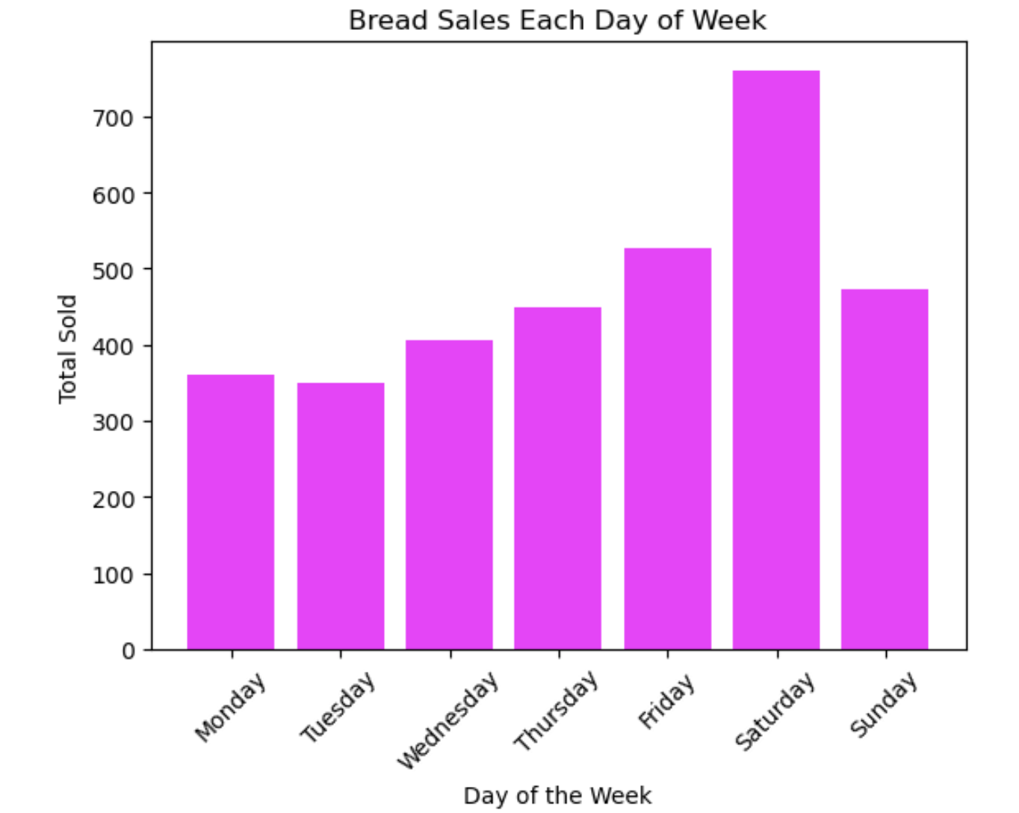
According to the bar chart above, bread has the most sales on Saturdays by well over 100 items and has the second highest sales on Friday. Monday, Tuesday and Wednesday have the least amount of bread sales and Thursday and Sunday have a similar amount.
After this analysis I decided to see which items were sold the most and which were sold the least in the entire data set. I created a new dataframe that was grouped by item sales and sorted the data from highest to lowest number of sales. The bakery sold many different items, so I decided to only look at the top 30 items sold. I then created a bar chart to show how much of each of the top 30 items was sold.
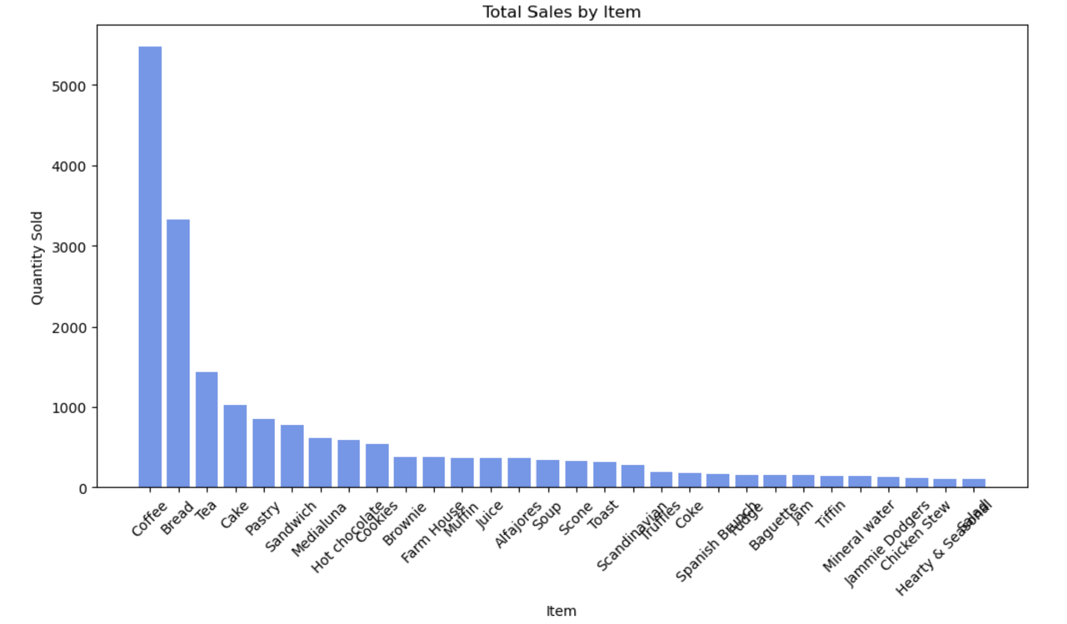
Acccording to this bar chart, the bakery sold the most amount of coffee as compared to other items by 2000 orders. Next after coffee came bread sales then tea which was almost another 2000 sale difference compared to bread sales. Cake and pastries had the next highest number of sales. Based on this chart I decided to focus my model on only the top 5 items sold.
Next while exploring the data I decided to look at how sales were based on the month. The data only ranged from October 2016 to April 2017 so I did not have all of the months to work with and did not get to see how sales per month might change over the years. For the data that I had to work with though I got the month from the datetime column and created a line chart to show how total sales changed over time.
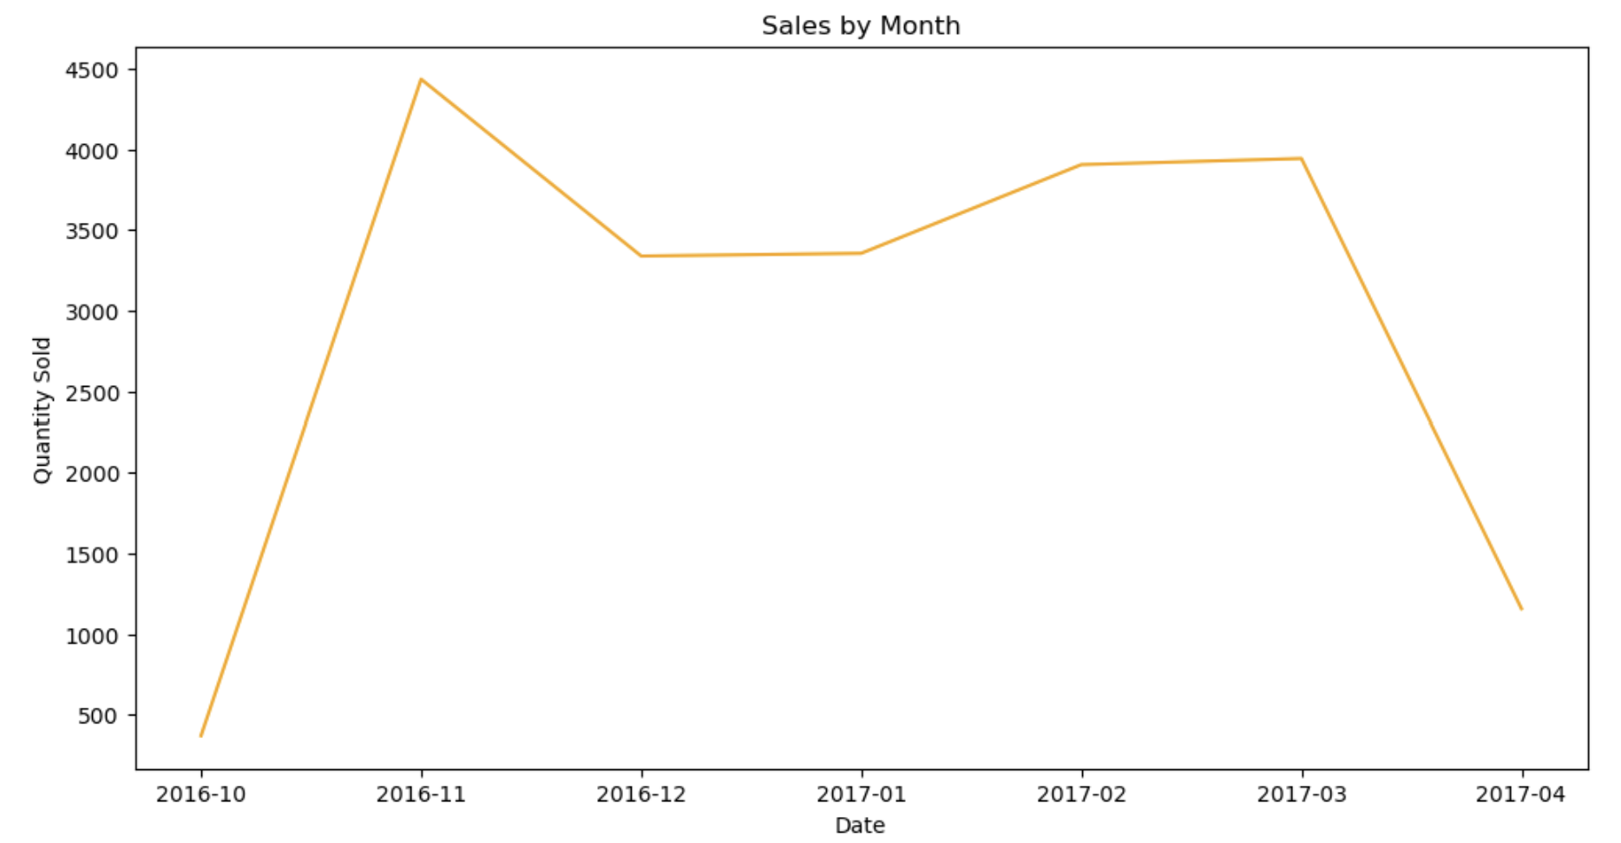
According to this chart, it looks like the lowest sales were in October 2016 and April 2017 however the data for these months were not for the entire month so they should be ignored in this context. In November the sales were highest then dropped significantly in December before slowly increasing again overtime. Based on this line chart I determined I did not have enough data to do an analysis based on the month.
The last part of the data that I explored was which day of the week the bakery sold the greatest number of items in general. I added a column that named the day of the week and grouped total sales by the day of the week and created a bar chart to visualize the results.
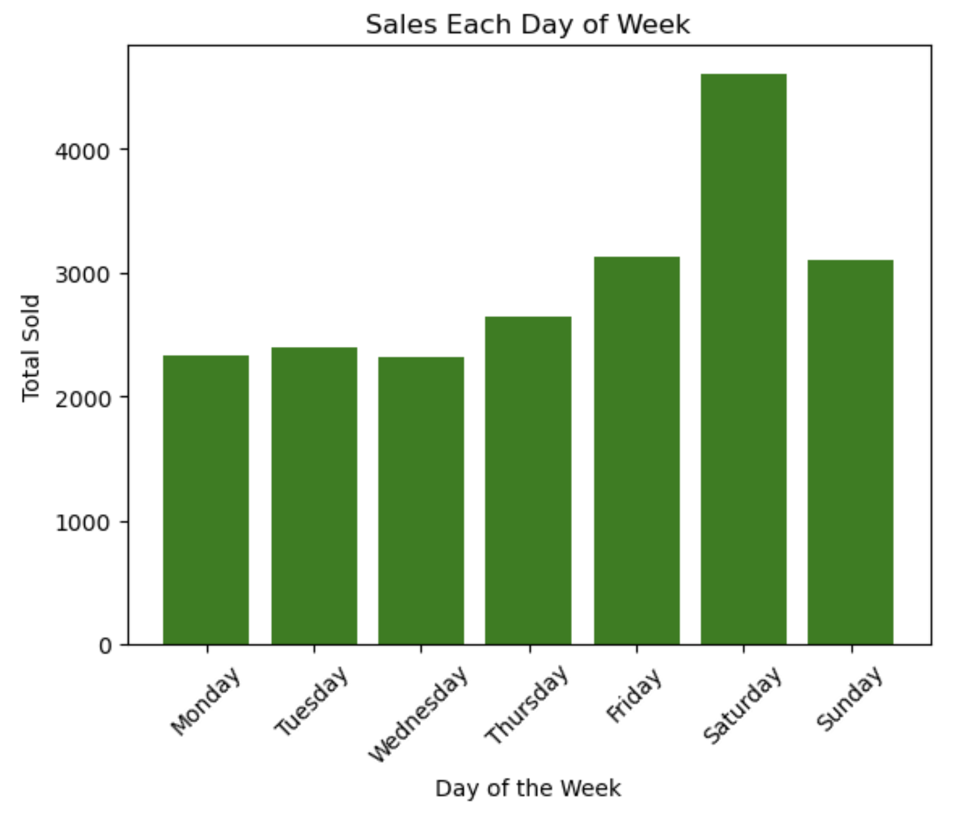
According to this chart the most sales occur on Saturday with Friday and Sunday having a similar number of sales and the second highest sales. Based on previous analysis, bread sales might be a reason that there is a higher number of sales on Saturday since we know that bread is sold most on Saturday.
Based on what was discovered in these charts, there are a lot of items sold by the bakery, and only a few items have the most sales including coffee, bread and tea, with coffee and bread being the highest by a lot. The most sales occurred on Saturdays, for every single item. Bread also had the most sales on Saturdays and Fridays and the least on Mondays and Tuesdays. This means that the most bread should be made for Saturdays and much less for Monday and Tuesday. The data was not collected long enough to see a pattern over each month, but the most sales was seen in November and least in December for the full months that were recorded. So far, it seems that the weekends have the most sales, followed by Fridays and Thursdays and the least amount are on Mondays, Tuesdays and Wednesdays. This shows that more bread, coffee and tea need to be available on weekends and Fridays as compared to other days of the week.
After exploring the data, I began the data cleansing process to prepare the data for model evaluation. I dropped the transaction column since it did not add any useful information and I added a column that had just the month number in case that might be helpful. I made all of the categorical columns lowercase so that the model wouldn’t get confused if some items were written in multiple ways (for example some all lowercase or some with upper case letters). I checked and made sure that there weren’t any missing values in the dataset that could mess up the analysis. At this point, I thought that I was going to create a linear regression model for every single item and tried setting up my data for that. I aggregated sales based on the day of the week (and forgot to drop the date column). I then created dummy variables for the day of week and item columns. This ended up creating a data frame with over 100 columns.
After realizing that the model would be very complex evaluating all of the items that the bakery sold I decided I needed to narrow my data down to only the top 5 items. These items included coffee, bread, tea, cake and pastry. I created a filtered dataframe for these 5 items and then created a new dataframe that summed sales and grouped the data based on the date and the items. Using the date column, I added a column to show which day of the week each transaction occurred and dropped the date column. I created dummy variables for the day of the week and item columns and used this data frame to create my linear regression model.
I used the linear regression model to determine daily sales and got an R2 value of 75.6% for the test set which was lower than the R2 value of the training set around 80%. If the model was overfit then the model would have a significantly higher number for the training set than the test set. The values are similar for both sets so I don’t believe that the model was overfit. I also decided to test the RMSE value for the test and training data. For the training data, the model values were off by 5.77 and with the testing data the model was off by 6.23 which is only a difference of 0.46 between them.
Since the model was only able to determine accurate results for 75% of the data with the testing/unseen data, I decided to try a random forest model to see if the results would be more accurate. The random forest model has a higher R2 value for the training data than the linear regression model, meaning it was able to predict more values correctly with this type of model while training. The testing data did not go up as much as the training data, which could be a risk for overfitting, however the R2 value for the test data still did go up a small amount from 75.6% to 76.7% which means the random forest model performed slightly better. The RMSE values for both the test and training data went down as compared to linear regression, which means that the predicted values were much closer to the actual values in the random forest model. Since submitting Milestone 3, I did not make any new changes to my code or add any new analysis.
Conclusion
The models were created with around a 75% accuracy which is lower than what I was hoping to achieve. I did discover that sales were highest on Saturdays and that this could be driven specifically by bread sales. These predictions were fairly strong, however there is still a lot of room for improvement. I do not believe that the model is ready to be deployed, and that changes can be made in order to make it more accurate. I would recommend collecting more data so that the model could see sales based on an entire year of data rather than just a few months so that more analysis could be done on the data. The model that I created is also limited to just determining sales of an item based on the day of the week and doesn’t take into account any potential fluctuations based on holidays or weather for example. With more data, these features could have been included and created a stronger model. Different times of the year may also affect bakery sales, but since there were only a few months to work with I only created a model based on sales on each day of the week. Some challenges that come along with creating a model like this includes change in customer preference and outside factors like a new bakery opening up nearby. The model would not be able to take this into consideration, and would have to be adjusted as time goes on. Overall, the model does predict sales for each day of the week with 75% accuracy but in order to be successfully deployed I think more data and an analysis based on the time of the year would be helpful.

